**Network Analysis Using Ping Tool**



**1. Introduction**



Ping is a basic network diagnostic tool that tests the reachability of a host on an Internet Protocol (IP) network. It measures the round-trip time for messages sent from the originating host to a destination computer. This Capture the Flag (CTF) scenario introduces beginners to the basics of network analysis using the Ping tool available at HackerTarget.

**2. Tools and Requirements**

* HackerTarget Ping Tool: An online tool for testing network reachability.

Link: <https://hackertarget.com/test-ping/>

**3. Scenario**

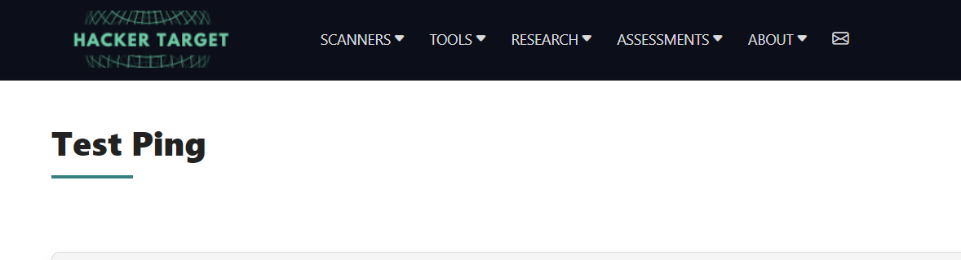

In this scenario, you will use the HackerTarget Ping Tool to analyze Google's IP address. Your tasks include understanding the response times, analyzing the number of hops, and interpreting the results to capture flags.

**4. Process to follow while Performing CTF**

Step 1: Go to your browser and visit the link:<https://hackertarget.com/test-ping/>   
Step 2: Use this tool to ping the IP address of Google (8.8.8.8) and analyze the results to solve the challenges and capture the flags.

**5. Let’s begin the Challenge**

**Questions**

Flag 1: Count the Number of Packets Sent

Question: How many packets were sent in the ping test to 8.8.8.8?

Answer: 4 packets

Flag Captured.

Flag 2: Count the Number of Packets Received

Question: How many packets were received in the ping test to 8.8.8.8?

Answer: 4 packets

Flag Captured.

Flag 3: Calculate Packet Loss

Question: What is the packet loss percentage in the ping test to 8.8.8.8?

Answer: 0%

Flag Captured.

**Hint**

